Adding Additional Family Members to a MyCareCorner Registered Account

Getting Started
Additional family members (spouse, children, and/or parents) can be added to a registered MyCareCorner account once a healthcare provider (hospital or clinic) provides the family member with an email or a printed copy of a registration instructions for MyCareCorner.

Using the Email
- To add the family member to your registered MyCareCorner account, click the link in the email instructions.

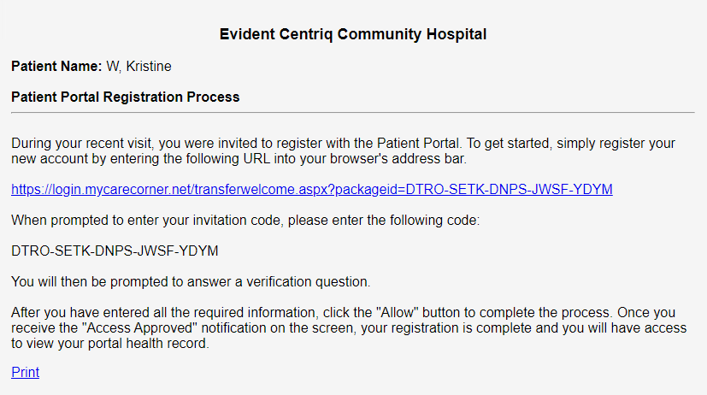

- The MyCareCorner page is launched. Click Continue.

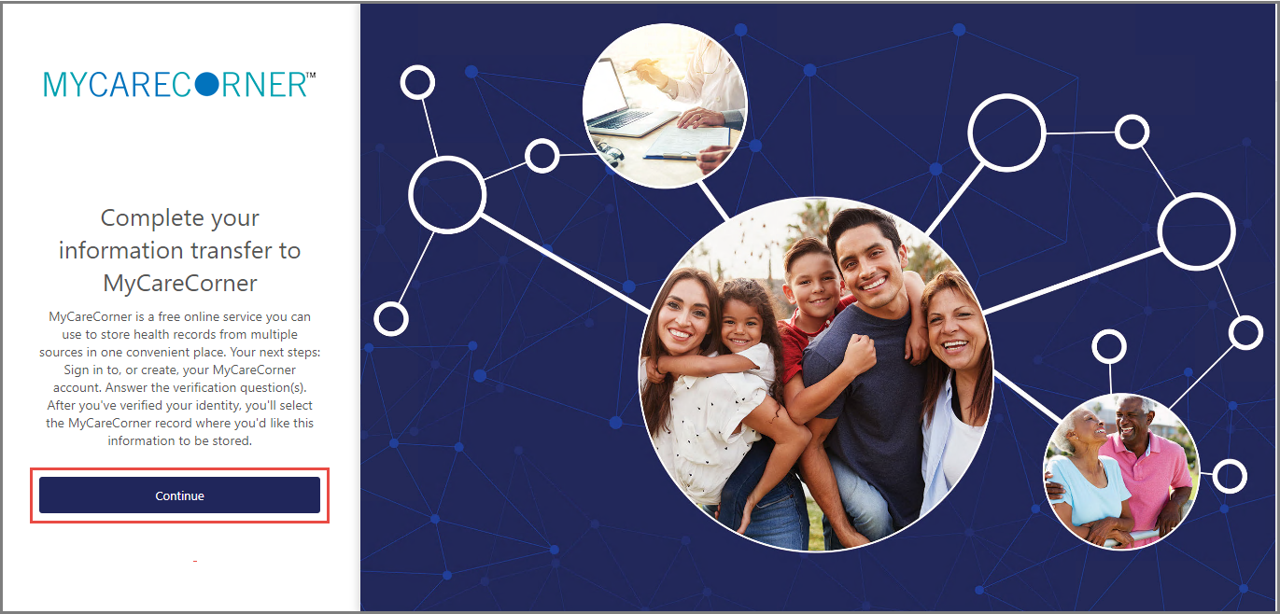

- The Invitation Code screen is displayed. When launching directly from the email, the invitation code is automatically displayed in the boxes. Click Submit.
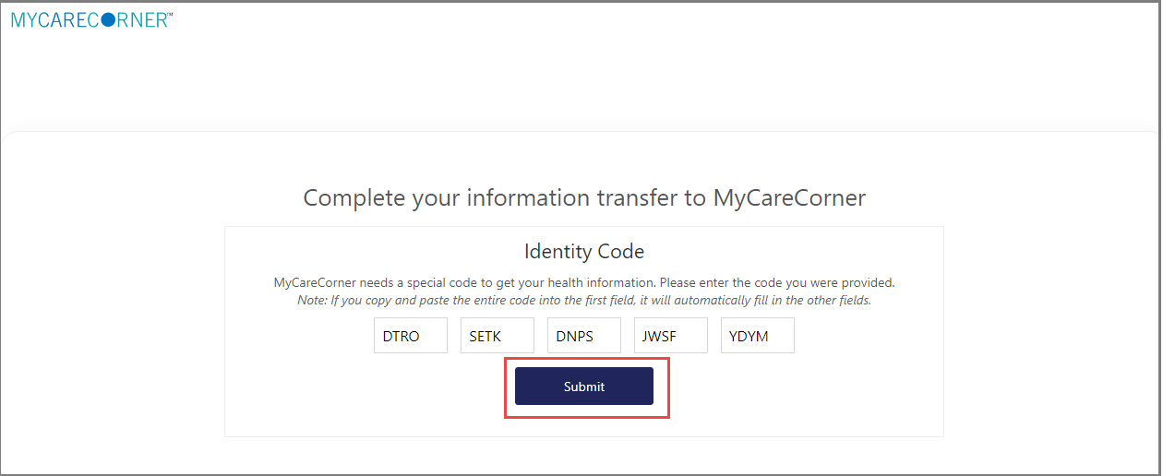

- The MyCareCorner Account screen is displayed. Enter the registered account member’s Email and Password and click Sign In.
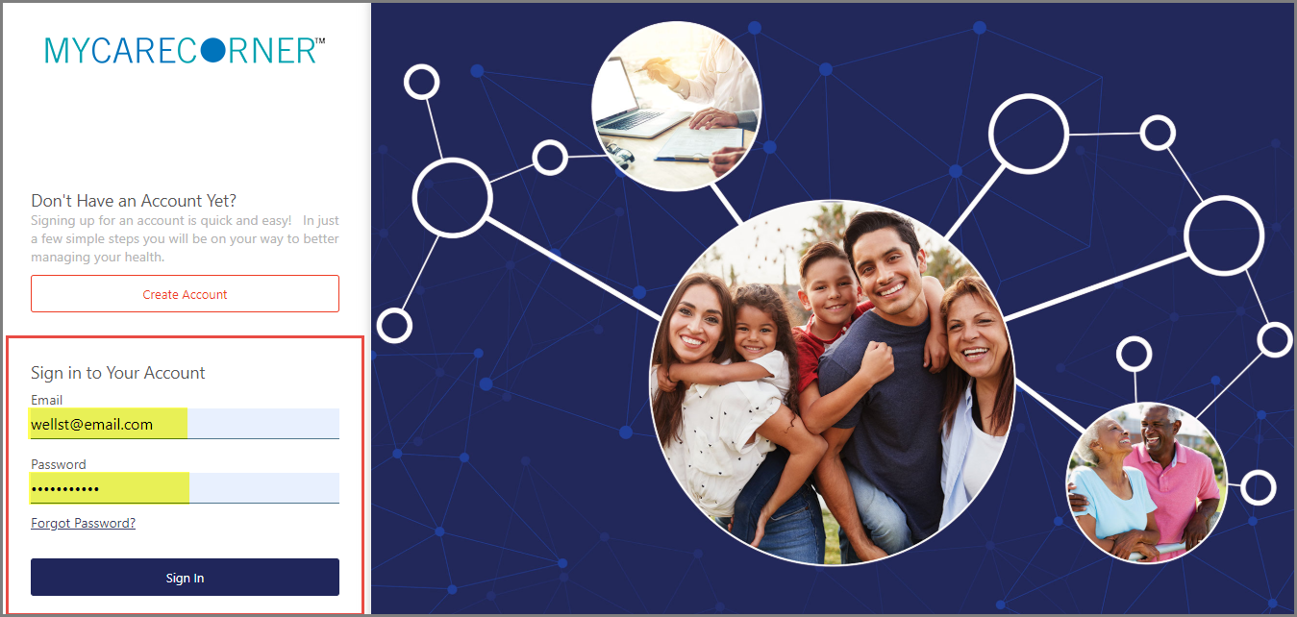

- To confirm the identity of your family member, enter the family member’s date of birth and click Submit.

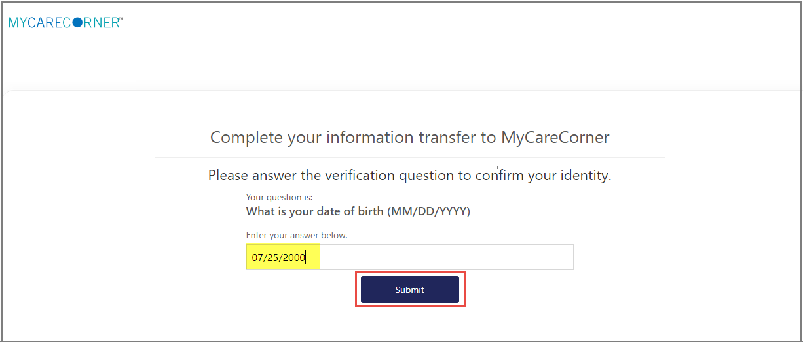

- The Information Transfer page is displayed. To add your family member’s record to your account, click Add record.
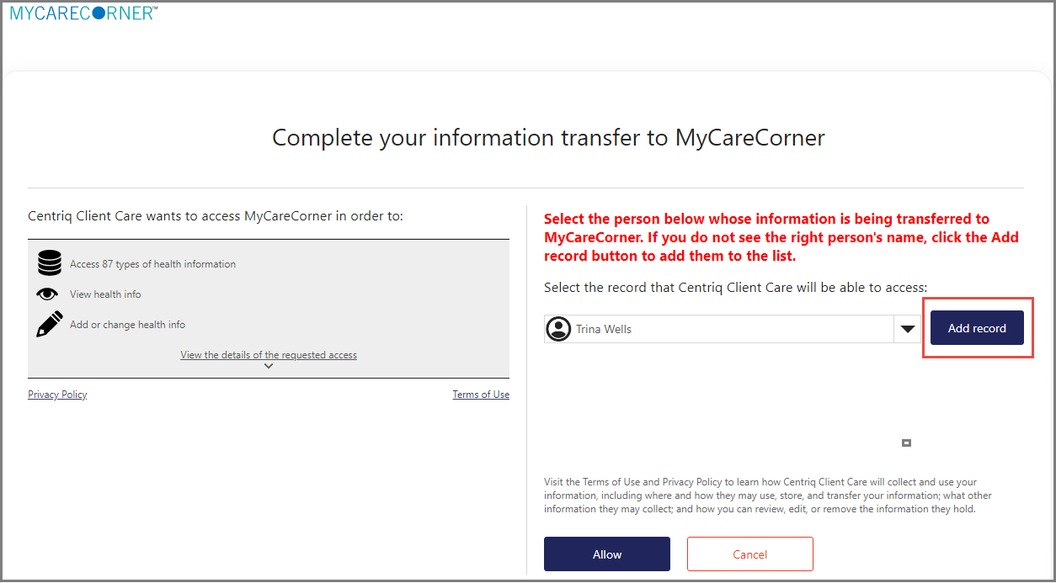

- On the Create New Record screen, enter the First Name, Last Name, Relationship, Sex, and Date of Birth of the family member’s record you are adding. Then, enter the characters you see in the field provided and click Create.
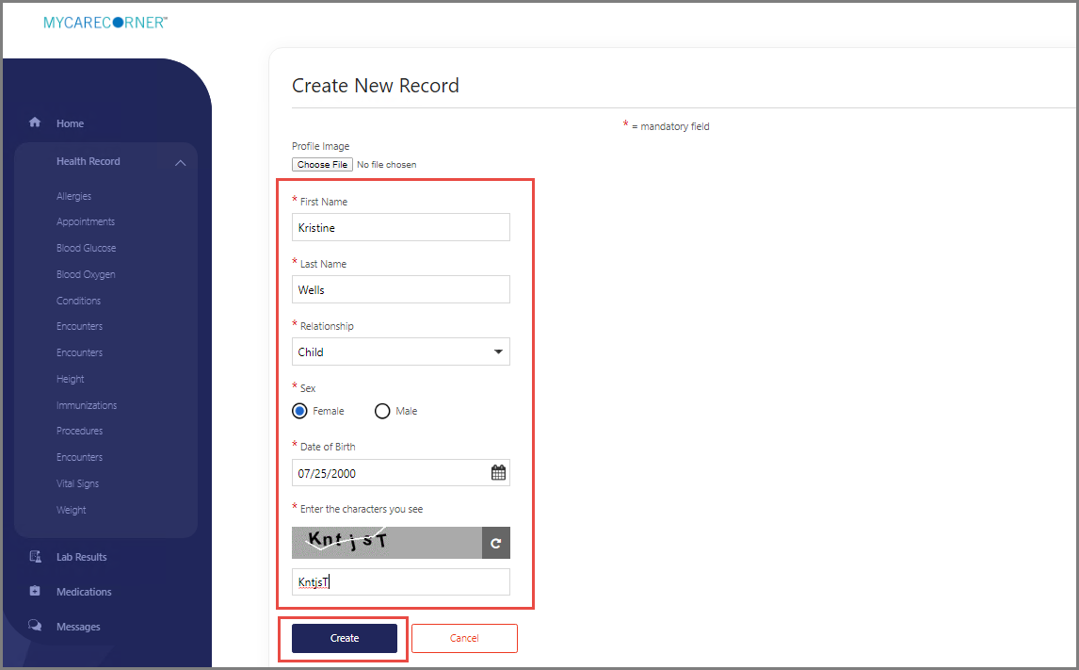

- The Information Transfer page is displayed. Select the family member’s record from the drop-down list and click Allow.
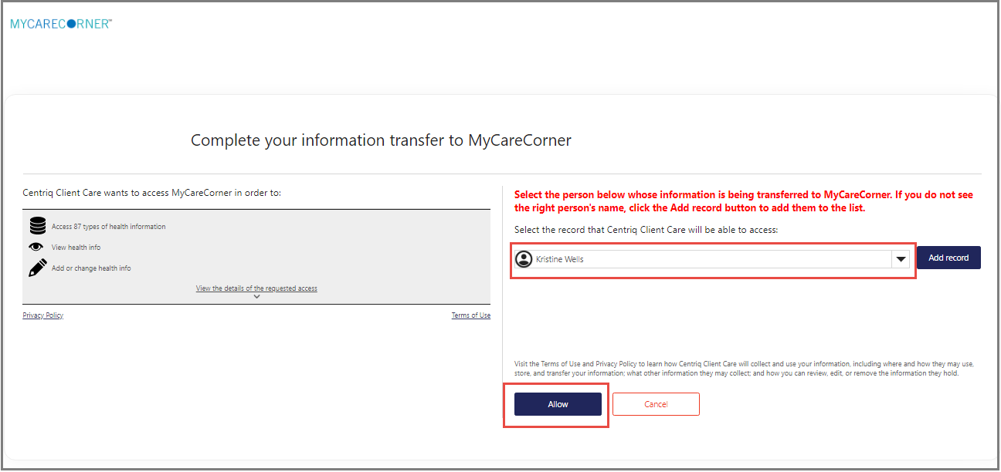

- The Access Approved screen is displayed. Click Home.
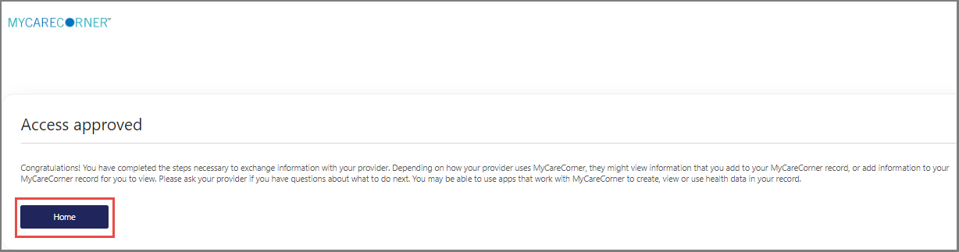
- As the Patient Dashboard is displayed, a Your Data is Loading message is displayed. Once the message disappears, refresh your browser and your family member’s health record will be displayed.

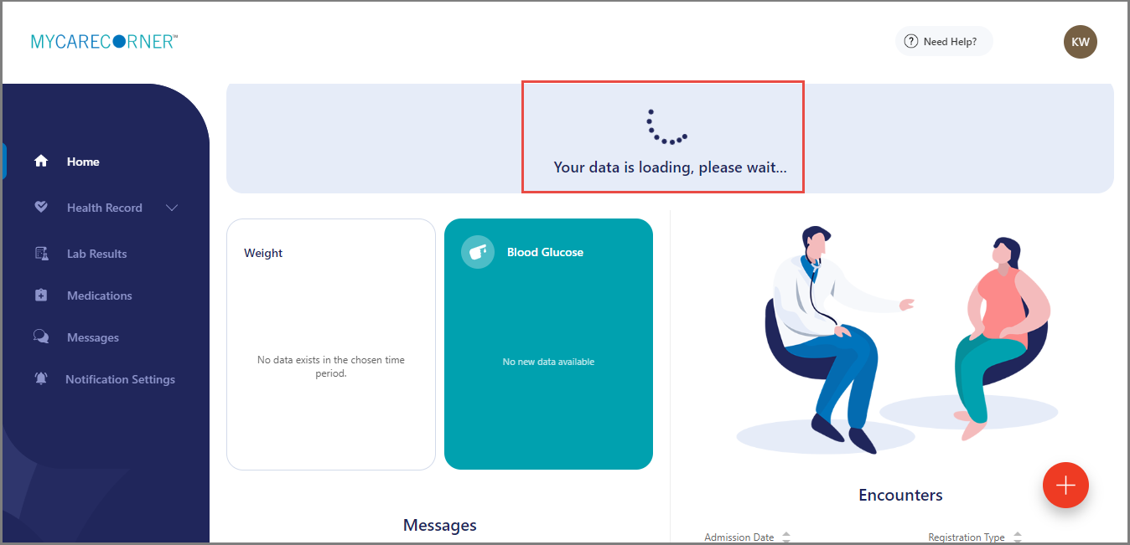

- To access your record and/or other linked records to your account, click the circle with your family members initials on it (in the upper-right corner of the screen). Then, select the health record you want to access.
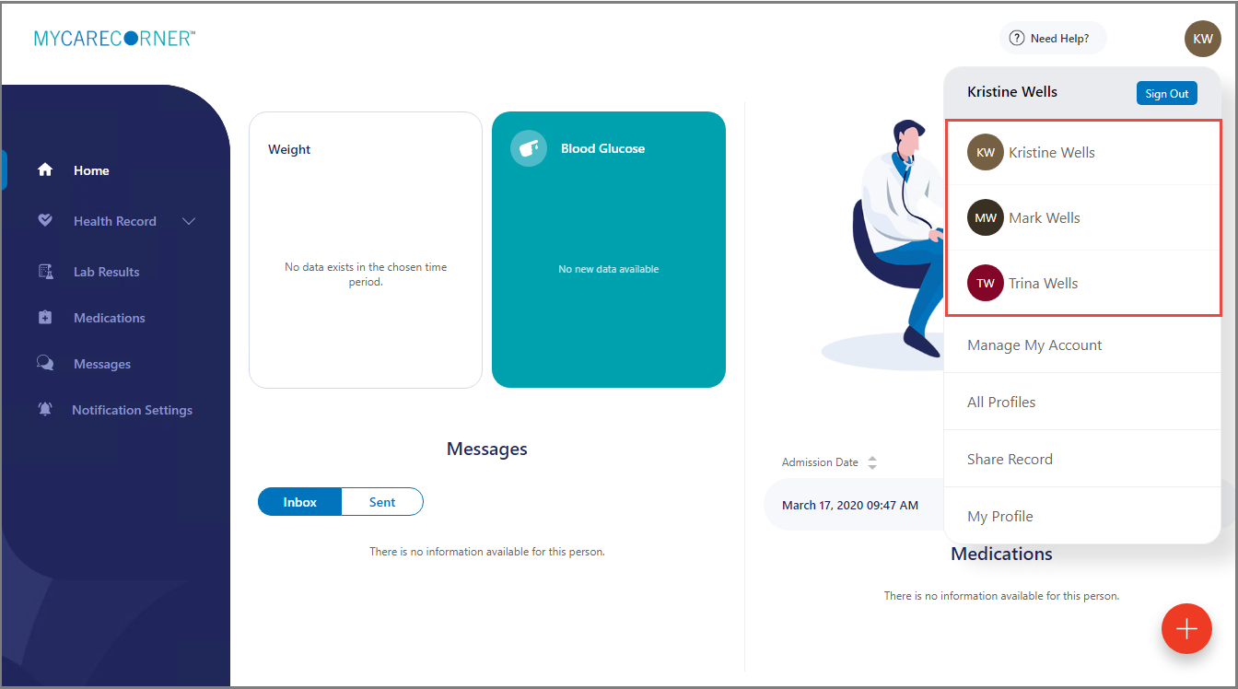

Using the Printed Instructions
- To add the family member to your registered MyCareCorner account, enter the URL from the printed invitation into the browser window.
- The MyCareCorner page is displayed. Click Continue.

- The Invitation Code screen is displayed. Enter the invitation code from your printed instructions. Click Submit.
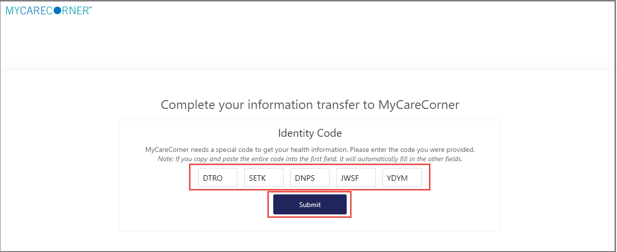
- The MyCareCorner Account screen is displayed. Enter the Email and Password of the registered account member and click Sign In.

- The remaining steps are the same as in the Using the Email section. See steps 5-11 above to complete the process.

