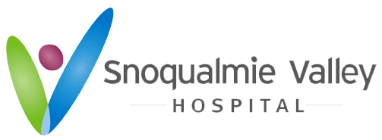

KING COUNTY PUBLIC HOSPITAL DISTRICT NO. 4

Board of Commissioners
2022 Meeting Schedule

Work Study Sessions 4 p.m.
Regular Monthly Board Meetings 5 p.m.
4th Thursday of Each Month
Due to COVID, Board Meetings are held online via Zoom. Please
contact jamiepa@snoqualmiehospital.org for meeting information.

January 27
February 24
March 24
April 28
May 26
June 23
July 28
August 25
September 22
October 27
December 1
December 29

The 2023 Public Budget Hearing will be set later in the year for a November date.

