COMMISSIONERS PRESENT
Kevin Hauglie, President
Jen Carter, Vice President
David Speikers, Secretary
Emma Herron
Dariel Norris

Excused
Dr. Tammy Moore, VP
OTHERS PRESENT
Renée Jensen, CEO
Patrick Ritter, CFO
Karyn Denton, COO
Dr. Thompson, CMO
Sherry Jennings, Director
Charles (Skip) Houser, General Counsel
Ronya Berndt, Quality Coordinator

CALL TO ORDER/ROLL CALL: President Hauglie called the Work Study meeting to order at 4:01 pm, followed by roll call. Commissioners participated in this meeting remotely.

INTRODUCTION – Ronya Berndt, Quality Program Coordinator: CEO Jensen introduced Ronya Berndt, Quality Program Coordinator.
SAFETYZONE PROGRAM REBOOT: A PowerPoint presentation was shared with the board. It was previously shared with Snoqualmie Valley Health leadership in order to educate the team about best practices and share achievements. Highlights of the PowerPoint are:

- How the culture of safety has changed at SVH over the last two years.
- Reporting feature is available to all staff. Reporting is non-punitive is encouraged by
SVH leadership.
- Staff are given the option to report anonymously or request follow-up.
- 2022 goal of 1,000 SafetyZone submissions was achieved.

ADJOURNMENT: The Work Study meeting adjourned at 4:48pm.
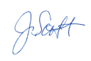
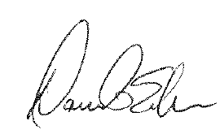
APPROVAL:

David Speikers, Board Secretary Jennifer Scott, Recording Clerk

